**PROJECT REPORT**

**ON**

**Microprocessor and Microcontroller based Women Security Device.**

Submitted by:

Lohit Sarkar, Roll No.:11900317027

Sooumodipta Basu Majumder, Roll No.:11900317012

Avishekh Sutradhar, Roll No.:11900317044

Under the guidance of

Mrs. Sarmistha Mondal

Assistant Professor, Dept. of ECE



**DEPARTMENT OF ELECTRONICS & COMMUNICATION ENGINEERING SILIGURI INSTITUTE OF TECHNOLOGY**

**PO: SUKNA, SILIGURI, PIN: 734009, WEST BENGAL**

**2020-2021**

**SILIGURI INSTITUTE OF TECHNOLOGY**

**PO: SUKNA, SILIGURI, PIN: 734 009, WEST BENGAL**

**2020-2021**

**DEPARTMENT OF ELECTRONICS & COMMUNICATION ENGINEERING**

**CERTIFICATE**

*Certified that the project work entitled ‘****Microprocessor and Microcontroller based Women Security Device****’ is a bonafide work carried out by:*

**Lohit Sarkar**  **Roll No:11900317027** 

**Sooumodipta Basu Majumder**  **Roll No: 11900317012**

**Avishekh Sutradhar**  **Roll No. 11900317044**

In partial fulfillment for the award for degree of BACHELOR OF TECHNOLOGY in ELECTRONICS & COMMUNICATION ENGINEERING of the Maulana Abul KalamAzad University of Technology, KOLKATA during the year 2020-2021. It is certified that all corrections/suggestions indicated for Internal Assessment have been incorporated in the report deposited in the Department. The project report has been approved as it satisfies the academic requirements in respect of Project Work prescribed for Bachelor of Engineering Degree.

-------------------------- --------------------------

Mr. Sarmistha Mondal Mr.Debojyoti Mishra

Assistant Professor, HOD,

Dept. of ECE, SIT. Dept. of ECE, SIT.

**ACKNOWLEDGEMENT**

We would like to express our heartfelt gratitude to all the people who have played a crucial role in the research for this project. Without their active cooperation, the preparation of this project could not have been completed within the specified time limit.

We are thankful to our respected Director, **Dr. Pradosh Kumar Adhvaryyu,** for motivating us to complete this project with entire focus and attention. We are also thankful to our project guide **Mrs. Sarmistha Mondal** who supported us throughout this project with utmost cooperation and patience and for helping us in doing this Project. **ABSTRACT:**

The goal/s of the project is to design a security device primarily for women that will call for aid during an emergency.

Nowadays, women’s safety is a major issue in India and also in other countries. Over thirty years, the incidence of sexual harassment in different industries has held steady. Various measures have been taken to reduce the risk of sexual assault on women by the control centre and their associations through SMS(Short Messaging Services) and GPS(Global Positioning System) system. But this is not enough because the police will take some time to reach the spot after locating the position. To cover this time gap there is a need for the victim to hold their ground on their own.

The principal purpose of this device is to close the gap in terms of physical strength. The average man is stronger than the average woman in terms of physical ability. Under normal circumstances, a woman cannot win against a man who is strangling her. Henceforth, she needs to resort to devices that will level the field. The device’s future prospects are immense if made available to the general public, at an affordable price.

● The number of assaults on women can be decreased.

● Will give women the means of protecting themselves.

● Women will feel safer than before.

These are some of the future prospects if the device is implemented properly.

**TABLE OF CONTENTS**

ACKNOWLEDGEMENTS ...........................................................................4

ABSTRACT ...........................................................................................5

**CHAPTER 1:**

INTRODUCTION ...................................................................... 10

**CHAPTER 2:**

COMPONENTS DESCRIPTION..........................................12

SIM900A...................................................................13-14

SIM900A GSM Module Pinout Configuration:......................................................................15-23

SIM900A GSM MODULE Features......................................23

How to Use SIM900A Module............................24-25

ISD1820 - Voice Recorder ..................26-27

Pin definition and Rating ...................................................28

ARDUINO............................................................31

Why Arduino?.................................................32

Global System for Mobile Communications (GSM)...................................................33

Network structure..............................................................................33-35

Global Positioning System........................................................................36-38

Jump wire...............................................................39-41

**CHAPTER 3:**

Interfacing Arduino to GSM Module..........................43-44

Interfacing ISD1820 Voice Recorder Module with Arduino.........................45-47

**CHAPTER 4:**

Software’s description..............................................................49

Arduino IDE.........................................................................49-51

**CHAPTER 5:**

Code for interfacing SIM900A with Arduino.......................................................................... 53

Code for interfacing ISD1820 with Arduino............................................................54-55

Code for Interfacing Arduino with SIM900A and ISD 1820:....................................................56-59

**CHAPTER 6:**

Operation...............................................................61

**CHAPTER 7:**

Result...................................................63

**CHAPTER 8:**

CONCLUSION...........................................................65

REFERENCE..................................................................................... 66

**List of Figures**

|  |  |  |
| --- | --- | --- |
| Fig. No. | Title | Page No. |
| 1 | SIM900A GSM Module | 13 |
| 2 | SIM900A GSM Module Pinout | 14 |
| 3 | SIM900A top view | 24 |
| 4 | ISD1820 | 26 |
| 5 | Circuit Diagram of ISD1820 | 27 |
| 6 | ISD1820 | 28 |
| 7 | ISD1820 modes | 29-30 |
| 8 | GSM network | 34 |
| 9 | SIM900 GSM Shield connected to PC through PL2303 USB to TTL converter. | 43 |
| 10 | GSM to Arduino Connection | 44 |
| 11 | Arduino UNO and ISD1820 Connection | 45 |
| 12 | Circuit Design | 46 |
| 13 | GUI of Arduino IDE | 50 |
| 14 | GUI of Arduino IDE | 61 |
| 15 | The module working with desirable result | 63 |

**CHAPTER 1**

**INTRODUCTION**

The protection of women and girls of concern is a core activity and an organizational priority for UNHCR. Members of UNHCR’s Executive Committee (ExCom) have specifically recognized the need to devote attention and resources to help ensure the protection of women since 19851 and of children since 1987.2 They reaffirmed this in the Agenda for Protection in 2002.3 In order to ensure the protection of these women and girls, it is important for each of us to understand and to recognize the particular challenges they face. These include challenges related to their gender, their roles and position in society. In this way, we can work more effectively to secure their protection on an equal basis to that of men and boys of concern.

The paper's purpose is based on a security device used to call aid in times of emergency. The primary audience for this device is women. The device will work as a defence system to protect the wearer from assault attempts. The Pivotal component for this device is an Arduino microprocessor. A GPS module, GSM module, and a voice recording module will be connected to the Arduino. The GPS and GSM module will send the user’s location and connect the call to an SOS number, and to the nearest police station. The device will also be equipped with self-defence mechanisms, like a stun gun. Miscellaneous components will be further added as the project progresses. The primary task of this project was to find the components for the prototype. The following steps are assembling the individual components, and coding the microprocessor/microcontroller. Components were found in a short time. Assembling the individual components is taking longer than expected since this is the first time a project like this is being undertaken. Components with which we do not have prior experience are not only being used but also we need to assemble them in a way that works with the other components as well. The coding part has not yet commenced, since the preceding step needed to be done before.

**CHAPTER 2**

**COMPONENTS DESCRIPTION:** In this project we have Used the following Sensors.

|  |  |  |
| --- | --- | --- |
| Sl. No. | Name | Quantity |
| 1. | SIM900A | 1 |
| 2. | ISD1820 | 1 |
| 3. | Arduino | 1 |
| 4. | GSM Module | 1 |
| 5. | GPS Module | 0 |
| 6. | Jump wire | As required |

This Section Contains the information regarding all the devices used in this project.

**SIM900A :**

The SIM900A is a readily available GSM/GPRS module,used in many mobile phones and PDA. The module can also be used for developing IOT (Internet of Things) and Embedded Applications. SIM900A is a dual-band GSM/GPRS engine that works on frequencies EGSM 900MHz and DCS 1800MHz. SIM900A features GPRS multi-slot class 10/ class 8 (optional) and supports the GPRS coding schemes CS-1, CS-2, CS-3 and CS-4.

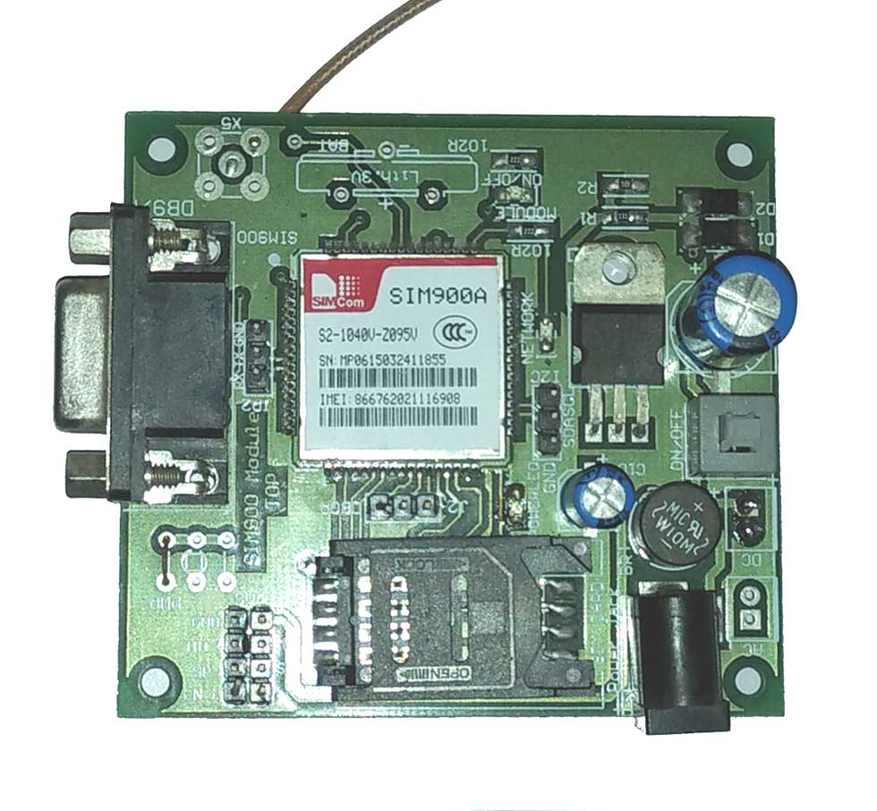

**Fig No. 1** SIM900A GSM Module

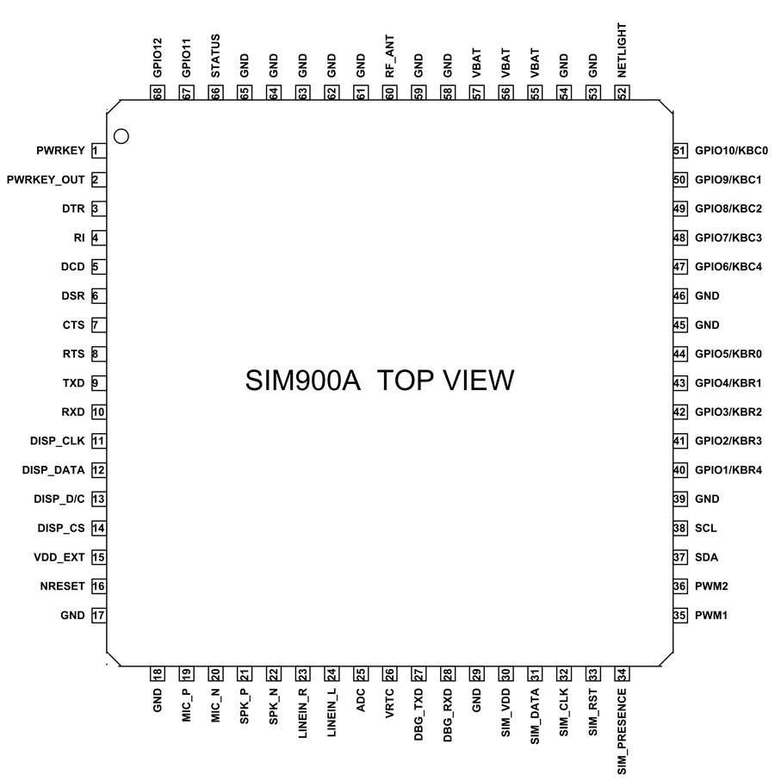

**Fig no. 2** SIM900A GSM Module Pinout

**SIM900A GSM Module Pinout Configuration:**

SIM900A is a 68 terminal device as shown in the pin diagram. We will describe the function of each pin below.

|  |  |  |
| --- | --- | --- |
| Pin Number | Pin Name | Description |
| 1 | PWRKEY | Voltage input for PWRKEY. PWRKEY should be pulled low to power on or power off the system.  The user should keep pressing the key for a short time when power on or power off the system because the system need margin time in order to assert the software. |
| 2 | PWRKEY_OUT | Connecting PWRKEY and PWRKEY_OUT for a short time then release also can power on or power off the module. |
| 3 | DTR | Data terminal Ready [Serial port ] |
| 4 | RI | Ring indicator [Serial port ] |
| 5 | DCD | Data carry detect [Serial port ] |
| 6 | DSR | Data Set Ready [Serial port ] |
| 7 | CTS | Clear to send [Serial port ] |
| 8 | RTS | Request to send [Serial port ] |
| 9 | TXD | Transmit data [Serial port ] |
| 10 | RXD | Receive data [Serial port ] |
| 11 | DISP _CLK | Clock for display [Display interface] |
| 12 | DISP_DATA | Display data output [Display interface] |
| 13 | DISP _D/C | Display data or command select [Display interface] |
| 14 | DISP _CS | Display Enable [Display interface] |
| 15 | VDD_EXT | 2.8V output power supply |
| 16 | NRESET | External reset input |
| 17,18,29,39,45,  46,53,54,58,59,  61,62,63,64,65 | GND | Ground |
| 19 | MIC_P | Microphone Positive |
| 20 | MIC_N | Microphone Negative |
| 21 | SPK_P | Speaker Positive |
| 22 | SPK_N | Speaker Negative |
| 23 | LINEIN_R | Right Channel input [External line inputs are available to directly mix or multiplex externally generated analog signals such as polyphonic tones from an external melody IC or music generated by an FM tuner IC or module.] |
| 24 | LINEIN_L | Left Channel Input |
| 25 | ADC | General purpose analog to digital converter. |
| 26 | VRTC | Current input for RTC when the battery is not supplied for the system.  Current output for backup battery when the main battery is present and the backup battery is in low voltage state. |
| 27 | DBG_TXD | Transmit pin [Serial interface for debugging and firmware upgrade ] |
| 28 | DBG_RXD | Receive pin [Serial interface for debugging and firmware upgrade ] |
| 30 | SIM_VDD | Voltage supply for SIM card |
| 31 | SIM_DATA | SIM data output |
| 32 | SIM_CLK | SIM clock |
| 33 | SIM_RST | SIM reset |
| 34 | SIM_PRESENCE | SIM detect |
| 35 | PWM1 | PWM Output |
| 36 | PWM2 | PWM Output |
| 37 | SDA | Serial Data [I2C] |
| 38 | SCL | Serial Clock [I2C] |
| 40,41,42,43,44  &  47,48,49,50,51 | KBR0 to KBR4  &  KBC4 to KBC0 | Keypad interface [ROWS & COLUMNS] |
| 52 | NETLIGHT | Indicate net status |
| 55,56,57 | VBAT | Three VBAT pins are dedicated to connect the supply voltage. The power supply of SIM900A has to be a single voltage source of VBAT= 3.4V to 4.5V. It must be able to provide sufficient current in a transmit burst which typically rises to 2A. |
| 60 | RF_ANT | Antenna connection |
| 66 | STATUS | Indicate working status |
| 67 | GPIO 11 | General Purpose Input/output |
| 68 | GPIO 12 | General Purpose Input/output |

**SIM900A GSM MODULE Features:**

* Single supply voltage: 3.4V – 4.5V
* Power saving mode: Typical power consumption in SLEEP mode is 1.5mA
* Frequency bands:SIM900A Dual-band: EGSM900, DCS1800. The SIM900A can search the two frequency bands automatically. The frequency bands also can be set by AT command.
* GSM class: Small MS
* GPRS connectivity:GPRS multi-slot class 10 (default) , GPRS multi-slot class 8 (option)
* Transmitting power: Class 4 (2W) at EGSM 900, Class 1 (1W) at DCS 1800
* Operating Temperature: -30ºC to +80ºC
* Storage Temperature: -5ºC to +90ºC
* DATA GPRS: download transfer max is 85.6KBps, Upload transfer max 42.8KBps
* Supports CSD, USSD, SMS, FAX
* Supports MIC and Audio Input
* Speaker Input
* Features keypad interface
* Features display interface
* Features Real Time Clock
* Supports UART interface
* Supports single SIM card
* Firmware upgrade by debug port
* Communication by using AT commands

**How to Use SIM900A Module:**

For understanding the usage of the module let us consider a simple application circuit as shown below.

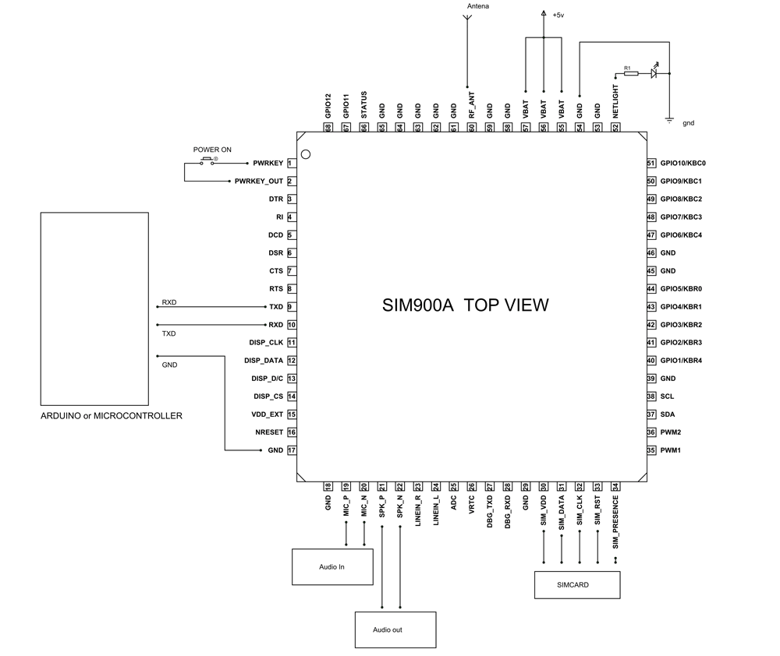

**Fig no. 3** SIM900A top view

As Shown above, the communication with this module is done through UART or RS232 Interface. The data is sent to the module or received from the module through the UART interface.

The module is typically connected to +4.0V standard power supply. It can work on +4.5V regulated power and any higher voltage may damage the module. And the power source should be able to deliver a peak current of 2A. The UART interface is established as shown in figure. All you need to do is connect the RXD of the module to TXD of Arduino and TXD is connected to RXD of ARDUINO. The ground of the controller and module must be connected for voltage reference. Here AUDIO IN is connected to MIC and AUDIO OUT is connected to a speaker or headset. And at last we need to connect a working GSM SIM card to the module. On powering the module the NETLIGHT LED will blink periodically to state successful connection.

After all connections are done,we need to write a program for the microcontroller to exchange data with modules. Since the data exchange sequence between controller and module is really complex we will use libraries prewritten for the module. You can download libraries for controllers or modules through their websites. Using these libraries makes communication easy. All you need to do is download these libraries and call them in programs. Once the header file is included, you can use simple commands in the program to tell the controller to send or receive data. The controller sends the data to the module through UART Interface based on protocol setup in libraries. The module sends this data to another GSM user using cellular network. If the module receives any data from the cellular network (or another GSM user) it will transmit it to the controller through UART serial communication.

This way we can use the GSM900A module to establish cellular connection.

**Applications**

* Cellular Communication
* Robotics
* Mobile Phone Accessories
* Servers
* Computer Peripherals
* Automobile
* USB Dongles

**ISD1820 - Voice Recorder:**

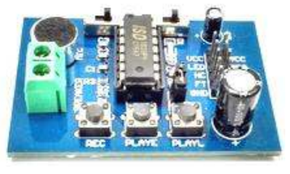

**Fig no. 4** ISD1820

**DESCRIPTION:** This module is base on ISD1820, which a multiple-message record/playback device. It can offer true single-chip voice recording, non-volatile storage, and playback capability for 8 to 20 seconds. The sample is 3.2k and the total 20s for the Recorder. This module use is very easy which you could direct control by push button on board or by Microcontroller such as Arduino, STM32, ChipKit etc. From these, you can easy control record , playback and repeat and so on.

**Feature:**

* Push-button interface, playback can be edge or level activated.
* Automatic power-down mode.
* On-chip 8っ speaker driver.
* Signal 3V Power Supply.
* Can be controlled both manually or by MCU.
* Sample rate and duration changeable by replacing a single resistor.
* Record up to 20 seconds of audio.

**Application Ideas:**

* Toys
* Alarm

**Cautions:** VCC is a signal of 3.3V, do not exceed this range, otherwise it will destroywill destroy the module.

**Schematic :**

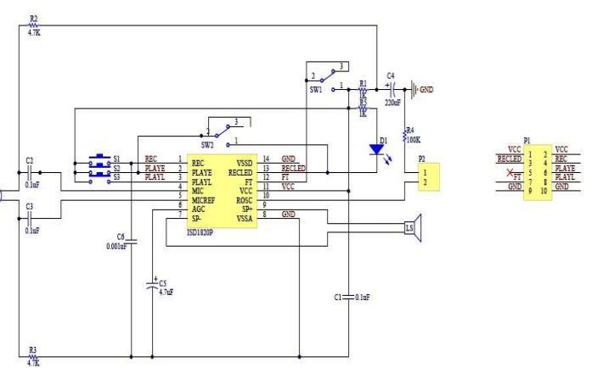

**Fig. No 5** Circuit Diagram of ISD1820

**Specification:**

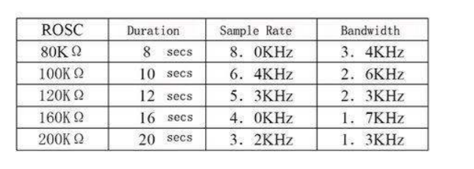

If you want to change record duration, an external resistor is necessary to select the record duration and sampling frequency, which can range from 8 - 20 seconds (4-12kHz sampling frequency). The Voice Record Module of our provide default connect 100k resistor through P2 by short cap. So the default record duration is 10s.

**Pin definition and Rating :**

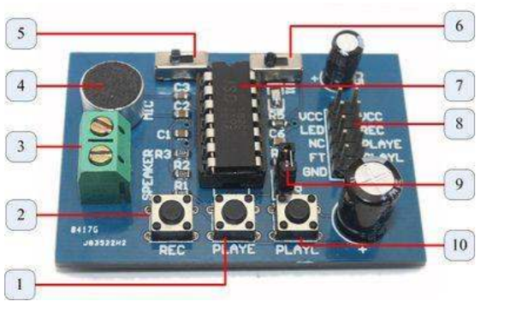

**Fig No.6** ISD1820

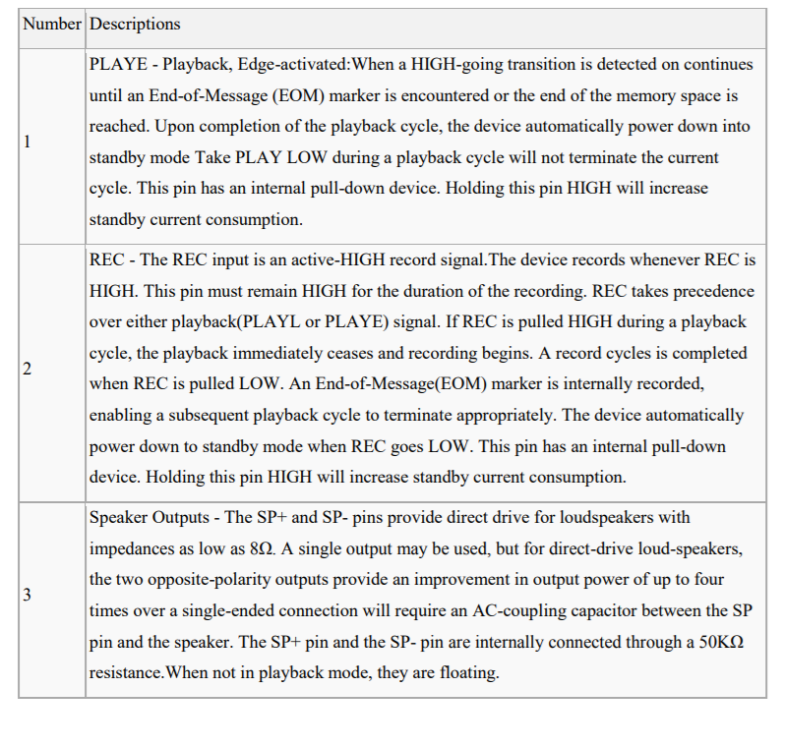

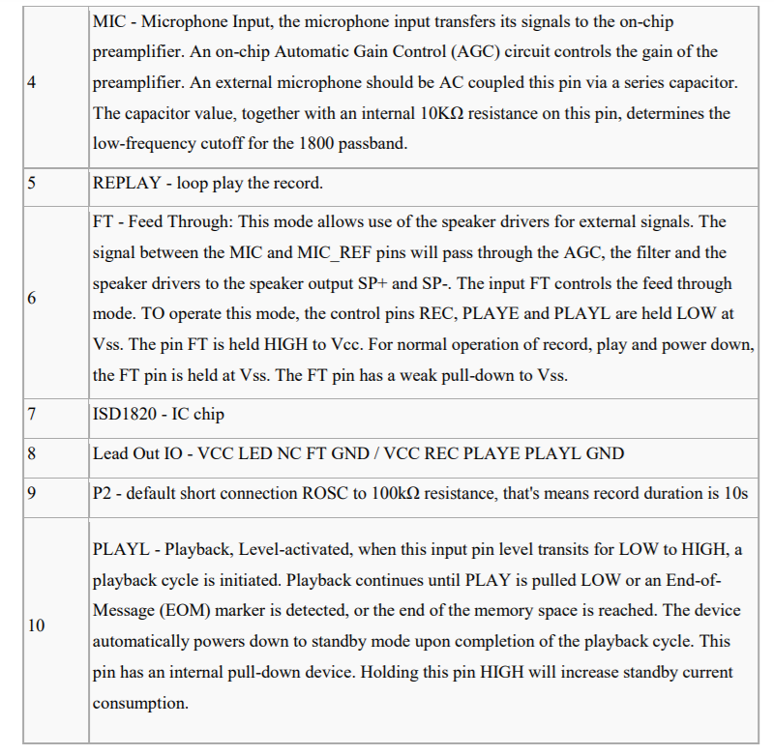

**Fig No. 7** ISD1820 modes

**ARDUINO:**

Arduino is an open-source electronics platform based on easy-to-use hardware and software. [**Arduino boards**](https://www.arduino.cc/en/Main/Products) are able to read inputs - light on a sensor, a finger on a button, or a Twitter message - and turn it into an output - activating a motor, turning on an LED, publishing something online. You can tell your board what to do by sending a set of instructions to the microcontroller on the board. To do so you use the [**Arduino programming language**](https://www.arduino.cc/en/Reference/HomePage) (based on [**Wiring**](http://wiring.org.co/)), and [**the Arduino Software (IDE)**](https://www.arduino.cc/en/Main/Software)**,** based on [**Processing**](https://processing.org/)**.**

Over the years Arduino has been the brain of thousands of projects, from everyday objects to complex scientific instruments. A worldwide community of makers - students, hobbyists, artists, programmers, and professionals - has gathered around this open-source platform, their contributions have added up to an incredible amount of [**accessible knowledge**](http://forum.arduino.cc/) that can be of great help to novices and experts alike.

Arduino was born at the Ivrea Interaction Design Institute as an easy tool for fast prototyping, aimed at students without a background in electronics and programming. As soon as it reached a wider community, the Arduino board started changing to adapt to new needs and challenges, differentiating its offer from simple 8-bit boards to products for IoT applications, wearable, 3D printing, and embedded environments. All Arduino boards are completely open-source, empowering users to build them independently and eventually adapt them to their particular needs. The [**software**](https://www.arduino.cc/en/Main/Software), too, is open-source, and it is growing through the contributions of users worldwide.

**Why Arduino?**

Thanks to its simple and accessible user experience, Arduino has been used in thousands of different projects and applications. The Arduino software is easy-to-use for beginners, yet flexible enough for advanced users. It runs on Mac, Windows, and Linux. Teachers and students use it to build low cost scientific instruments, to prove chemistry and physics principles, or to get started with programming and robotics. Designers and architects build interactive prototypes, musicians and artists use it for installations and to experiment with new musical instruments. Makers, of course, use it to build many of the projects exhibited at the Maker Faire, for example. Arduino is a key tool to learn new things. Anyone - children, hobbyists, artists, programmers - can start tinkering just following the step by step instructions of a kit, or sharing ideas online with other members of the Arduino community.

There are many other microcontrollers and microcontroller platforms available for physical computing. Parallax Basic Stamp, Netmedia's BX-24, Phidgets, MIT's Handyboard, and many others offer similar functionality. All of these tools take the messy details of microcontroller programming and wrap it up in an easy-to-use package. Arduino also simplifies the process of working with microcontrollers, but it offers some advantage for teachers, students, and interested amateurs over other systems:

* **Inexpensive** - Arduino boards are relatively inexpensive compared to other microcontroller platforms. The least expensive version of the Arduino module can be assembled by hand, and even the pre-assembled Arduino modules cost less than $50
* **Cross-platform** - The Arduino Software (IDE) runs on Windows, Macintosh OSX, and Linux operating systems. Most microcontroller systems are limited to Windows.
* **Simple, clear programming environment** - The Arduino Software (IDE) is easy-to-use for beginners, yet flexible enough for advanced users to take advantage of as well. For teachers, it's conveniently based on the Processing programming environment, so students learning to program in that environment will be familiar with how the Arduino IDE works.
* **Open source and extensible software** - The Arduino software is published as open source tools, available for extension by experienced programmers. The language can be expanded through C++ libraries, and people wanting to understand the technical details can make the leap from Arduino to the AVR C programming language on which it's based. Similarly, you can add AVR-C code directly into your Arduino programs if you want to.

**Open source and extensible hardware** - The plans of the Arduino boards are published under a Creative Commons license, so experienced circuit designers can make their own.

**Global System for Mobile Communications** (**GSM**)**:**

The Global System for Mobile Communications (GSM) is a standard developed by the [European Telecommunications Standards Institute](https://en.wikipedia.org/wiki/European_Telecommunications_Standards_Institute) (ETSI) to describe the protocols for second-generation ([2G](https://en.wikipedia.org/wiki/2G)) digital [cellular networks](https://en.wikipedia.org/wiki/Cellular_network) used by mobile devices such as mobile phones and tablets. It was first deployed in [Finland](https://en.wikipedia.org/wiki/Finland) in December 1991.By the mid-2010s, it became a global standard for mobile communications achieving over 90% market share, and operating in over 193 countries and territories.

2G networks developed as a replacement for first generation ([1G](https://en.wikipedia.org/wiki/1G)) analog cellular networks. The GSM standard originally described a digital, circuit-switched network optimized for [full duplex](https://en.wikipedia.org/wiki/Duplex_(telecommunications)#Full_duplex) voice [telephony](https://en.wikipedia.org/wiki/Telephony). This expanded over time to include data communications, first by [circuit-switched transport](https://en.wikipedia.org/wiki/Circuit_Switched_Data), then by [packet](https://en.wikipedia.org/wiki/Network_packet) data transport via [General Packet Radio Service](https://en.wikipedia.org/wiki/General_Packet_Radio_Service) (GPRS), and [Enhanced Data Rates for GSM Evolution](https://en.wikipedia.org/wiki/Enhanced_Data_Rates_for_GSM_Evolution) (EDGE).

Subsequently, the [3GPP](https://en.wikipedia.org/wiki/3GPP) developed third-generation ([3G](https://en.wikipedia.org/wiki/3G)) [UMTS](https://en.wikipedia.org/wiki/UMTS) standards, followed by the fourth-generation ([4G](https://en.wikipedia.org/wiki/4G)) [LTE Advanced](https://en.wikipedia.org/wiki/LTE_Advanced) and the fifth-generation [5G](https://en.wikipedia.org/wiki/5G) standards, which do not form part of the ETSI GSM standard.

**Network structure**

The network is structured into several discrete sections:

* Base station subsystem – the base stations and their controllers
* Network and Switching Subsystem – the part of the network most similar to a fixed network, sometimes just called the "core network"
* GPRS Core Network – the optional part which allows packet-based Internet connections
* Operations support system (OSS) – network maintenance

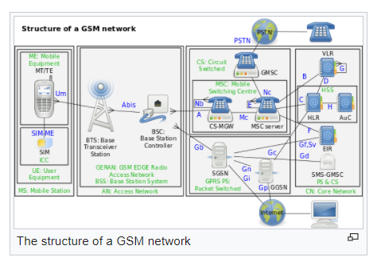

**Fig No. 8** GSM network

**Base-station subsystem:**

GSM utilizes a [cellular network](https://en.wikipedia.org/wiki/Cellular_network), meaning that [cell phones](https://en.wikipedia.org/wiki/Cell_phone) connect to it by searching for cells in the immediate vicinity. There are five different cell sizes in a GSM network:

* [macro](https://en.wikipedia.org/wiki/Macrocell)
* [micro](https://en.wikipedia.org/wiki/Microcell)
* [pico](https://en.wikipedia.org/wiki/Picocell)
* [femto](https://en.wikipedia.org/wiki/Femtocell), and
* [umbrella cells](https://en.wikipedia.org/w/index.php?title=Umbrella_cells&action=edit&redlink=1)

The coverage area of each cell varies according to the implementation environment. Macro cells can be regarded as cells where the [base-station](https://en.wikipedia.org/wiki/Base_station) [antenna](https://en.wikipedia.org/wiki/Antenna_(electronics)) is installed on a mast or a building above average rooftop level. Micro cells are cells whose antenna height is under average rooftop level; they are typically deployed in urban areas. Picocells are small cells whose coverage diameter is a few dozen meters; they are mainly used indoors. Femtocells are cells designed for use in residential or [small-business](https://en.wikipedia.org/wiki/Small_business) environments and connect to a [telecommunications service provider](https://en.wikipedia.org/wiki/Telecommunications_service_provider)'s network via a [broadband-internet](https://en.wikipedia.org/wiki/Broadband_internet) connection. Umbrella cells are used to cover shadowed regions of smaller cells and to fill in gaps in coverage between those cells.

Cell horizontal radius varies – depending on antenna height, [antenna gain](https://en.wikipedia.org/wiki/Antenna_gain), and [propagation](https://en.wikipedia.org/wiki/Propagation_(disambiguation)) conditions – from a couple of hundred meters to several tens of kilometers. The longest distance the GSM specification supports in practical use is 35 kilometres (22 mi). There are also several implementations of the concept of an extended cell,[[19]](https://en.wikipedia.org/wiki/GSM#cite_note-19) where the cell radius could be double or even more, depending on the antenna system, the type of terrain, and the [timing advance](https://en.wikipedia.org/wiki/Timing_advance).

GSM supports indoor coverage – achievable by using an indoor picocell base station, or an [indoor repeater](https://en.wikipedia.org/wiki/Cellular_repeater) with distributed indoor antennas fed through power splitters – to deliver the radio signals from an antenna outdoors to the separate indoor distributed antenna system. Picocells are typically deployed when significant call capacity is needed indoors, as in shopping centers or airports. However, this is not a prerequisite, since indoor coverage is also provided by in-building penetration of radio signals from any nearby cell.

**Subscriber Identity Module (SIM)**

One of the key features of GSM is the [**Subscriber Identity Module**](https://en.wikipedia.org/wiki/Subscriber_Identity_Module), commonly known as a SIM card. The SIM is a detachable [smart card](https://en.wikipedia.org/wiki/Smart_card) containing the user's subscription information and phone book. This allows the user to retain his or her information after switching handsets. Alternatively, the user can change operators while retaining the handset simply by changing the SIM.

**Phone locking**

Sometimes [mobile network operators](https://en.wikipedia.org/wiki/Mobile_network_operator) restrict handsets that they sell for exclusive use in their own network. This is called [SIM locking](https://en.wikipedia.org/wiki/SIM_lock) and is implemented by a software feature of the phone. A subscriber may usually contact the provider to remove the lock for a fee, utilize private services to remove the lock, or use software and websites to unlock the handset themselves. It is possible to hack past a phone locked by a network operator.

In some countries and regions (e.g., [Bangladesh](https://en.wikipedia.org/wiki/Bangladesh), [Belgium](https://en.wikipedia.org/wiki/Belgium), [Brazil](https://en.wikipedia.org/wiki/Brazil), [Canada](https://en.wikipedia.org/wiki/Canada), [Chile](https://en.wikipedia.org/wiki/Chile), [Germany](https://en.wikipedia.org/wiki/Germany), [Hong Kong](https://en.wikipedia.org/wiki/Hong_Kong), [India](https://en.wikipedia.org/wiki/India), [Iran](https://en.wikipedia.org/wiki/Iran), [Lebanon](https://en.wikipedia.org/wiki/Lebanon), [Malaysia](https://en.wikipedia.org/wiki/Malaysia), [Nepal](https://en.wikipedia.org/wiki/Nepal), [Norway](https://en.wikipedia.org/wiki/Norway), [Pakistan](https://en.wikipedia.org/wiki/Pakistan), [Poland](https://en.wikipedia.org/wiki/Poland), [Singapore](https://en.wikipedia.org/wiki/Singapore), [South Africa](https://en.wikipedia.org/wiki/South_Africa), [Sri Lanka](https://en.wikipedia.org/wiki/Sri_Lanka), [Thailand](https://en.wikipedia.org/wiki/Thailand)) all phones are sold unlocked due to the abundance of dual SIM handsets and operators.

**Global Positioning System**

The **Global Positioning System** (**GPS**), originally **Navstar GPS**, is a [satellite-based radionavigation](https://en.wikipedia.org/wiki/Radionavigation-satellite_service) system owned by the [United States government](https://en.wikipedia.org/wiki/United_States_government) and operated by the [United States Space Force](https://en.wikipedia.org/wiki/United_States_Space_Force). It is one of the [global navigation satellite systems](https://en.wikipedia.org/wiki/Satellite_navigation) (GNSS) that provides [geolocation](https://en.wikipedia.org/wiki/Geolocation) and [time information](https://en.wikipedia.org/wiki/Time_transfer) to a [GPS receiver](https://en.wikipedia.org/wiki/Satellite_navigation_device) anywhere on or near the Earth where there is an unobstructed line of sight to four or more GPS satellites. Obstacles such as mountains and buildings block the relatively weak [GPS signals](https://en.wikipedia.org/wiki/GPS_signals).

The GPS does not require the user to transmit any data, and it operates independently of any telephonic or internet reception, though these technologies can enhance the usefulness of the GPS positioning information. The GPS provides critical positioning capabilities to military, civil, and commercial users around the world. The United States government created the system, maintains it, and makes it freely accessible to anyone with a GPS receiver.

The GPS project was started by the [U.S. Department of Defense](https://en.wikipedia.org/wiki/United_States_Department_of_Defense) in 1973, with the first prototype spacecraft launched in 1978 and the full constellation of 24 satellites operational in 1993. Originally limited to use by the United States military, civilian use was allowed from the 1980s following an executive order from President [Ronald Reagan](https://en.wikipedia.org/wiki/Ronald_Reagan) after the [Korean Air Lines Flight 007](https://en.wikipedia.org/wiki/Korean_Air_Lines_Flight_007) incident. Advances in technology and new demands on the existing system have now led to efforts to modernize the GPS and implement the next generation of [GPS Block IIIA](https://en.wikipedia.org/wiki/GPS_Block_IIIA) satellites and Next Generation Operational Control System (OCX). Announcements from Vice President [Al Gore](https://en.wikipedia.org/wiki/Al_Gore) and the [Clinton Administration](https://en.wikipedia.org/wiki/Clinton_Administration) in 1998 initiated these changes, which were authorized by the [U.S. Congress](https://en.wikipedia.org/wiki/United_States_Congress) in 2000.

During the 1990s, GPS quality was degraded by the United States government in a program called "Selective Availability"; this was discontinued on May 1, 2000 by a law signed by President [Bill Clinton](https://en.wikipedia.org/wiki/Bill_Clinton).

The GPS service is provided by the United States government, which can selectively deny access to the system, as happened to the Indian military in 1999 during the [Kargil War](https://en.wikipedia.org/wiki/Kargil_War), or degrade the service at any time. As a result, several countries have developed or are in the process of setting up other global or regional satellite navigation systems. The Russian Global Navigation Satellite System ([GLONASS](https://en.wikipedia.org/wiki/GLONASS)) was developed contemporaneously with GPS, but suffered from incomplete coverage of the globe until the mid-2000s. GLONASS can be added to GPS devices, making more satellites available and enabling positions to be fixed more quickly and accurately, to within two meters (6.6 ft).China's [BeiDou Navigation Satellite System](https://en.wikipedia.org/wiki/BeiDou_Navigation_Satellite_System) began global services in 2018, and finished its full deployment in 2020. There are also the European Union [Galileo positioning system](https://en.wikipedia.org/wiki/Galileo_(satellite_navigation)), and India's [NavIC](https://en.wikipedia.org/wiki/Indian_Regional_Navigation_Satellite_System). Japan's [Quasi-Zenith Satellite System](https://en.wikipedia.org/wiki/Quasi-Zenith_Satellite_System) (QZSS) is a GPS [satellite-based augmentation system](https://en.wikipedia.org/wiki/Satellite-based_augmentation_system) to enhance GPS's accuracy in [Asia-Oceania](https://en.wikipedia.org/wiki/Asia-Pacific), with satellite navigation independent of GPS scheduled for 2023.

When selective availability was lifted in 2000, GPS had about a five-meter (16 ft) accuracy. GPS receivers that use the L5 band can have much higher accuracy, pinpointing to within 30 centimeters (11.8 in). As of May 2021, 16 GPS satellites are broadcasting L5 signals, and the signals are considered pre-operational, scheduled to reach 24 satellites by approximately 2027.

**Fundamentals:**

The GPS receiver calculates its own position and time based on data received from multiple GPS [satellites](https://en.wikipedia.org/wiki/Satellite). Each satellite carries an accurate record of its position and time, and transmits that data to the receiver.

The satellites carry very stable [atomic clocks](https://en.wikipedia.org/wiki/Atomic_clocks) that are synchronized with one another and with ground clocks. Any drift from time maintained on the ground is corrected daily. In the same manner, the satellite locations are known with great precision. GPS receivers have clocks as well, but they are less stable and less precise.

Since the speed of [radio waves](https://en.wikipedia.org/wiki/Radio_wave) is constant and independent of the satellite speed, the time delay between when the satellite transmits a signal and the receiver receives it is proportional to the distance from the satellite to the receiver. At a minimum, four satellites must be in view of the receiver for it to compute four unknown quantities (three position coordinates and clock deviation from satellite time).

More detailed description:

Each GPS satellite continually broadcasts a signal ([carrier wave](https://en.wikipedia.org/wiki/Carrier_wave) with [modulation](https://en.wikipedia.org/wiki/Modulation)) that includes:

* A [pseudorandom](https://en.wikipedia.org/wiki/Pseudorandom_binary_sequence) code (sequence of ones and zeros) that is known to the receiver. By time-aligning a receiver-generated version and the receiver-measured version of the code, the time of arrival (TOA) of a defined point in the code sequence, called an epoch, can be found in the receiver clock time scale
* A message that includes the time of transmission (TOT) of the code epoch (in GPS time scale) and the satellite position at that time

Conceptually, the receiver measures the TOAs (according to its own clock) of four satellite signals. From the TOAs and the TOTs, the receiver forms four [time of flight](https://en.wikipedia.org/wiki/Time_of_flight) (TOF) values, which are (given the speed of light) approximately equivalent to receiver-satellite ranges plus time difference between the receiver and GPS satellites multiplied by speed of light, which are called as pseudo-ranges. The receiver then computes its three-dimensional position and clock deviation from the four TOFs.

In practice the receiver position (in three dimensional [Cartesian coordinates](https://en.wikipedia.org/wiki/Cartesian_coordinate_system) with origin at the Earth's center) and the offset of the receiver clock relative to the GPS time are computed simultaneously, using the [navigation equations](https://en.wikipedia.org/wiki/Global_Positioning_System#Navigation_equations) to process the TOFs.

The receiver's Earth-centered solution location is usually converted to [latitude](https://en.wikipedia.org/wiki/Latitude), [longitude](https://en.wikipedia.org/wiki/Longitude) and height relative to an ellipsoidal Earth model.

**Jump wire:**

A **jump wire** (also known as jumper, jumper wire, jumper cable, DuPont wire or cable) is an [electrical wire](https://en.wikipedia.org/wiki/Electrical_wire), or group of them in a cable, with a connector or pin at each end (or sometimes without them – simply "tinned"), which is normally used to interconnect the components of a [breadboard](https://en.wikipedia.org/wiki/Breadboard) or other prototype or test circuit, internally or with other equipment or components, without soldering.

Individual jump wires are fitted by inserting their "end connectors" into the slots provided in a breadboard, the [header connector](https://en.wikipedia.org/wiki/Pin_header#Header_connector) of a circuit board, or a piece of test equipment.

**Types:**

There are different types of jumper wires. Some have the same type of [electrical connector](https://en.wikipedia.org/wiki/Electrical_connector) at both ends, while others have different connectors. Some common connectors are:

* Solid tips – are used to connect on/with a breadboard or female header connector. The arrangement of the elements and ease of insertion on a breadboard allows increasing the mounting density of both components and jump wires without fear of short-circuits. The jump wires vary in size and colour to distinguish the different working signals.
* [Crocodile clips](https://en.wikipedia.org/wiki/Crocodile_clip) – are used, among other applications, to temporarily bridge sensors, buttons and other elements of prototypes with components or equipment that have arbitrary connectors, wires, [screw terminals](https://en.wikipedia.org/wiki/Screw_terminal), etc.
* [Banana connectors](https://en.wikipedia.org/wiki/Banana_connector) – are commonly used on test equipment for DC and low-frequency AC signals.
* [Registered jack](https://en.wikipedia.org/wiki/Registered_jack) (RJnn) – are commonly used in telephone (RJ11) and computer networking (RJ45).
* [RCA connectors](https://en.wikipedia.org/wiki/RCA_connector) – are often used for audio, low-resolution composite video signals, or other low-frequency applications requiring a [shielded cable](https://en.wikipedia.org/wiki/Shielded_cable).
* [RF connectors](https://en.wikipedia.org/wiki/RF_connector) – are used to carry [radio frequency](https://en.wikipedia.org/wiki/Radio_frequency) signals between circuits, test equipment, and antennas.
* RF jumper cables - Jumper cables is a smaller and more bendable corrugated cable which is used to connect antennas and other components to network cabling. Jumpers are also used in base stations to connect antennas to radio units. Usually the most bendable jumper cable diameter is 1/2".

**Jumper (computing)**

In electronics and particularly computing, a **jumper** is a short length of conductor used to close, open or bypass part of an electronic circuit. They are typically used to set up or configure printed circuit boards, such as the motherboards of computers. The process of setting a jumper is often called **strapping**.

**Design**

Jumper pins (points to be connected by the jumper) are arranged in groups called *jumper blocks*, each group having at least one pair of contact points. An appropriately sized conductive sleeve called a jumper, or more technically, a shunt jumper, is slipped over the pins to complete the circuit. Jumpers must be electrically conducting; they are usually encased in a non-conductive block of plastic for convenience. This also avoids the risk that an unshielded jumper will accidentally short out something critical (particularly if it is dropped on a live circuit).

**Use**

When a jumper is placed over two or more jumper pins, an electrical connection is made between them, and the equipment is thus instructed to activate certain settings accordingly. For example, with older PC systems, CPU speed and voltage settings were often made by setting jumpers.

Some documentation may refer to setting the jumpers to on, off, closed, or open. When a jumper is on or covering at least two pins it is a closed jumper, when a jumper is off, is covering only one pin, or the pins have no jumper it is an open jumper.

Jumperless designs have the advantage that they are usually fast and easy to set up, often require little technical knowledge, and can be adjusted without having physical access to the circuit board. With PCs, the most common use of jumpers is in setting the operating mode for [ATA](https://en.wikipedia.org/wiki/AT_Attachment) drives (master, slave, or cable select), though this use is declining with the rise of SATA drives. Jumpers have been used since the beginning of printed circuit boards.

**Permanent parts of a circuit**

Some printed wiring assemblies, particularly those using single-layer circuit boards, include short lengths of wire soldered between pairs of points. These wires are called jumpers, but unlike jumpers used for configuration settings, they are intended to permanently connect the points in question. They are used to solve layout issues of the printed wiring, providing connections that would otherwise require awkward (or in some cases, impossible) routing of the conductive traces. In some cases a resistor of 0 ohms is used instead of a wire, as these may be installed by the same robotic assembly machines that install real resistors and other components.

**CHAPTER 3**

**Interfacing Arduino to GSM Module**

In order to operate SIM900 GSM Shield directly over PC, you need to connect it to PC using any USB to TTL converter.

Below image shows SIM900 GSM Shield connected to PC through PL2303 USB to TTL converter.

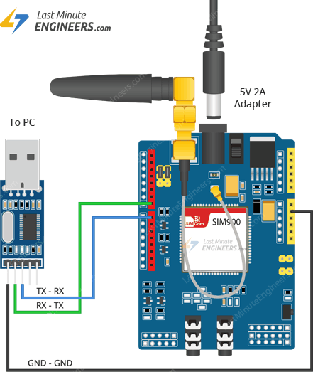

**Fig No. 9** SIM900 GSM Shield connected to PC through PL2303 USB to TTL converter.

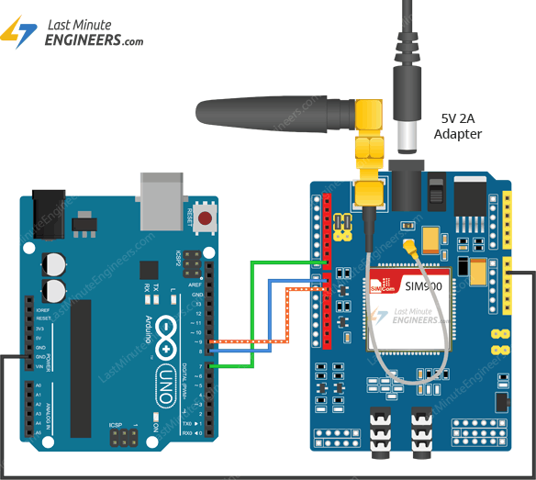

**Fig No. 10** GSM to Arduino Connection

# **Interfacing ISD1820 Voice Recorder Module with Arduino:**

It is clear that the ISD1820 Voice Recorder Module can work independently without any microcontroller. But controlling the record and play back function with the help of a microcontroller like Arduino for example, gives you an opportunity to expand the functionality of the module to a complex application level.

Imagine a situation where you are designing a security system which should automatically record the voice upon detection of a movement. This would be possible only if you Interface ISD1820 Voice Recorder Module with Arduino (or any microcontroller).

**Circuit Diagram:**

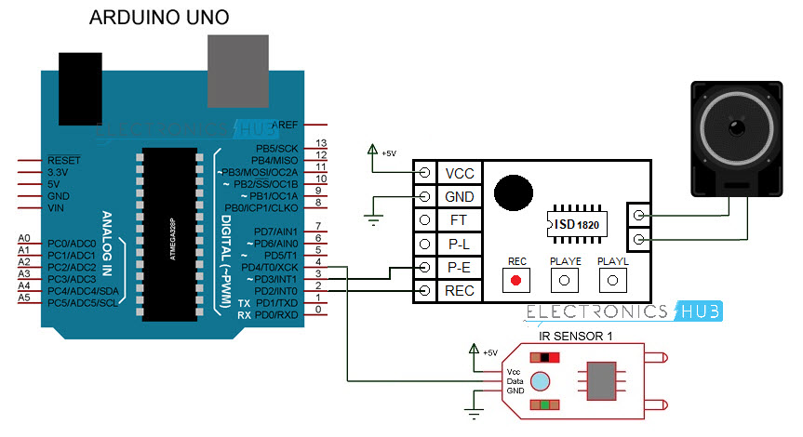

**Fig No. 11** Arduino UNO and ISD1820 Connection

**Circuit Design:**

The SP+ and SP- pins of the ISD1820 Module are connected to the terminals of the speaker. VCC and GND of the Module are connected to +5V and GND. The REC and PLAY E pins are connected to Digital IO Pins 2 and 3 of Arduino.

A reflective type Infrared Sensor is used here and the digital output of the sensor is connected to Pin 4 of Arduino.

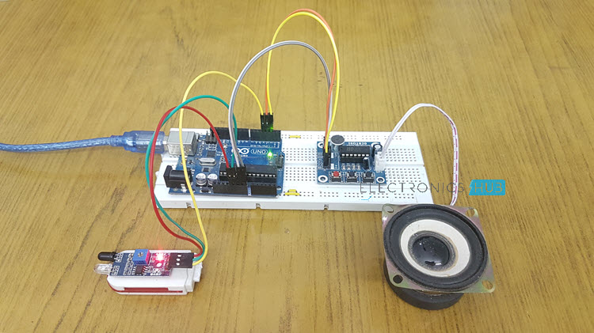

**Fig No. 12** Circuit Design

**Working:**

Make the connections as per the circuit diagram and provide power to the circuit. When there is no object in front of the IR Sensor, its output is LOW and Arduino does nothing. When there is an object in front of the IR Sensor, its output becomes HIGH and the Arduino then starts recording a message by making the REC Pin HIGH for about 5 Seconds. During this time, the LED connected to Pin 13 is lit up to indicate that the module is recording a message. After recording the message, the message is played back by making the PLAY E pin HIGH for about 6 Seconds.

**CHAPTER 4**

**Software’s Description:**

**Arduino IDE:**

The Arduino Integrated Development Environment (IDE) is a cross-platform application that is written in functions from C and C++. It is used to write and upload programs to Arduino compatible boards, but also, with the help of third-party cores, other vendor development boards.

The source code for the IDE is released under the GNU General Public License, version 2. The Arduino IDE Supports the language C and C++ using special rule of Code Structuring. The Arduino IDE supplies a software library from the Wiring project which provides many common input and output procedures.

The basic functionality of the program written in this IDE:

Basically, the user written code only requires two basic functions.

**void setup():** This block is generally used to initialize all the devices attached with it. It is also used to initialize variables, pin modes, start using libraries etc. The setup() function only runs once, after each powerup or reset of the Arduino board. An example code is given below for better understanding.

/*SAMPLE CODE*/

*int buttonPin = 3;*

*void setup()*

*{*

*Serial.begin(9600);*

*pinMode (buttonPin, INPUT);*

*}*

**void loop():** After creating a setup () function, which initializes and sets the initial values, the loop () function does precisely what its name suggests, and loops consecutively, allowing the program to change and respond. Use it to actively control the Arduino board.

/*SAMPLE CODE*/

*void loop()*

*{*

*if (digitalRead(buttonPin) == HIGH) {*

*Serial.write('H');*

*}*

*else*

*{*

*Serial.write('L');*

*}*

*delay(1000);*

*}*

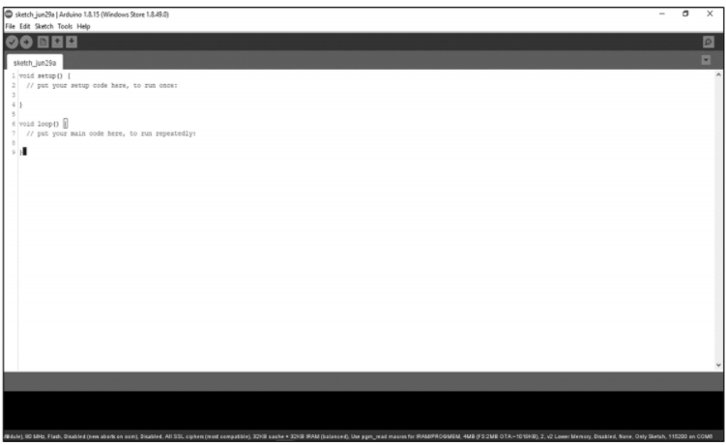

**Fig No. 13** GUI of Arduino IDE

**Features:**

* **inexpensive.**
* **open source in hardware.**
* **don't need to external programmer (Burner)**
* **programming ease.**
* **open source in software.**
* **IDE Software operates on any operating system.**

**CHAPTER 5**

**Code for interfacing SIM900A with Arduino:**

*void setup()*

*{*

*//Set Exact Baud rate of the GSM/GPRS Module.*

*Serial.begin(9600);*

*Serial.print("\r");*

*delay(1000);*

*Serial.print("AT+CMGF=1\r");*

*delay(1000);*

*/*Replace XXXXXXXXXX to 10 digit mobile number & ZZ to 2 digit country code*/*

*Serial.print("AT+CMGS=\"+918759637883\"\r");*

*delay(1000);*

*//The text of the message to be sent.*

*Serial.print("Help please");*

*delay(1000);*

*Serial.write(0x1A);*

*delay(1000);*

*}*

*void loop()*

*{*

*// put your main code here, to run repeatedly:*

*setup();*

*delay(5000);*

*}*

**Code for interfacing ISD1820 with Arduino:**

*int rec=2;*

*int play=3;*

*int sensor=4;*

*int led=13;*

*void setup()*

*{*

*pinMode(rec,OUTPUT);*

*pinMode(play,OUTPUT);*

*pinMode(led,OUTPUT);*

*pinMode(sensor,INPUT);*

*digitalWrite(rec,LOW);*

*digitalWrite(play,LOW);*

*digitalWrite(led,LOW);*

*}*

*void loop()*

*{*

*digitalWrite(led,HIGH);*

*digitalWrite(rec,HIGH);*

*delay(5000);*

*digitalWrite(led,LOW);*

*digitalWrite(rec,LOW);*

*delay(1000);*

*digitalWrite(play,HIGH);*

*delay(6000);*

*digitalWrite(play,LOW);*

*}*

**Code for Interfacing Arduino with SIM900A and ISD 1820:**

*int rec=2;*

*int play=3;*

*int sensor=4;*

*int led=13;*

*void setup()*

*{*

*// put your setup code here, to run once:*

*Serial.begin(9600);*

*Serial.print("\r");*

*delay(1000);*

*Serial.print("AT+CMGF=1\r");*

*delay(1000);*

*/*Replace XXXXXXXXXX to 10 digit mobile number & ZZ to 2 digit country code*/*

*Serial.print("AT+CMGS=\"+918759637883\"\r");*

*delay(1000);*

*//The text of the message to be sent.*

*Serial.print("Help Sutra");*

*delay(1000);*

*Serial.write(0x1A);*

*delay(1000);*

*delay(5000);*

*void record();*

*}*

*void loop()*

*{*

*// put your main code here, to run repeatedly:*

*// put your main code here, to run repeatedly:*

*setup();*

*delay(5000);*

*digitalWrite(led,HIGH);*

*digitalWrite(rec,HIGH);*

*delay(5000);*

*digitalWrite(led,LOW);*

*digitalWrite(rec,LOW);*

*delay(1000);*

*digitalWrite(play,HIGH);*

*delay(6000);*

*digitalWrite(play,LOW);*

*}*

*/*void send_message()*

*{*

*//Set Exact Baud rate of the GSM/GPRS Module.*

*Serial.begin(9600);*

*Serial.print("\r");*

*delay(1000);*

*Serial.print("AT+CMGF=1\r");*

*delay(1000);*

*/*Replace XXXXXXXXXX to 10 digit mobile number & ZZ to 2 digit country code*

*Serial.print("AT+CMGS=\"+918759637883\"\r");*

*delay(1000);*

*//The text of the message to be sent.*

*Serial.print("Help Sutra");*

*delay(1000);*

*Serial.write(0x1A);*

*delay(1000);*

*}*/*

*void record()*

*{*

*pinMode(rec,OUTPUT);*

*pinMode(play,OUTPUT);*

*pinMode(led,OUTPUT);*

*pinMode(sensor,INPUT);*

*digitalWrite(rec,LOW);*

*digitalWrite(play,LOW);*

*digitalWrite(led,LOW);*

*}*

**CHAPTER 6**

**Operation:**

The block diagram of the prototype/project is attached below to give an idea of how the

components are connected.

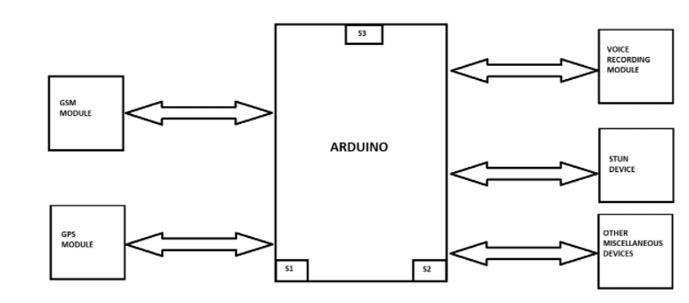

**Fig No. 14** Block Diagram

1. The S1 switch is used to activate the system.

2. The S2 switch is used to activate the defence system.

3. The S3 switch is used to activate the whole system and will transmit the SOS message,

location, and connect the call to the speed dial number and to the police.

**CHAPTER 7Result:**

The project is working as it is supposed to be. On activation, it sends a message to the undersigned number every five seconds and starts recording.

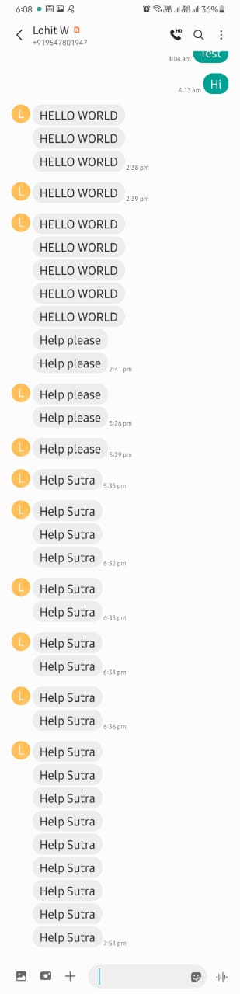

**Fig No. 15** The module working with desirable result

**CHAPTER 8**

**Conclusion:**

The paper's purpose is based on a security device used to call aid in times of emergency.

The primary audience for this device is women. The device will work as a defence system to

protect the wearer from assault attempts. The Pivotal component for this device is an Arduino

microprocessor. A GPS module, GSM module, and a voice recording module will be connected

to the Arduino. The GPS and GSM module will send the user’s location and connect the call to

an SOS number, and to the nearest police station.Miscellaneous components like stun devices and other components have room for addition.

**References:**

1. A. Al-Mazloum et al, 2013, “GPS and SMS-Based Child Tracking System Using Smart Phone”, International journal of electrical, computer, energetic, electronics and communication Vol.7, No. 2.

2. A.SANTHIYA, B.HARIPRAKASH, J.MITHILAESH, Dr.K.VALARMATHI., Android Based Women Tracking System Using GPS and GSM . Journal for Advanced Research in Applied Sciences.

3. GSM and ADHAR based safety management system through Smart Poles: A step towards safety for humanistic Society (Women) Sourav Kumar Pradhan, Vivi Holo, Shanti Bhusan Acharya.

4. Siddam Kavitha* et al. (IJITR) INTERNATIONAL JOURNAL OF INNOVATIVE TECHNOLOGY AND RESEARCH Volume No.4, Issue No.5, August – September 2016, 4140-4142.

5. Patel Anuj Kumar et al; International Journal of Advance Research and Development.

6. Women Security Assistance System with GPS Tracking and Messaging System Shivam Bhatia, Surabhi Dash Swati Sharma Ritika Bose, Harpuneet Singh.